2022 BYM Women’s Retreat Working Group Annual Report

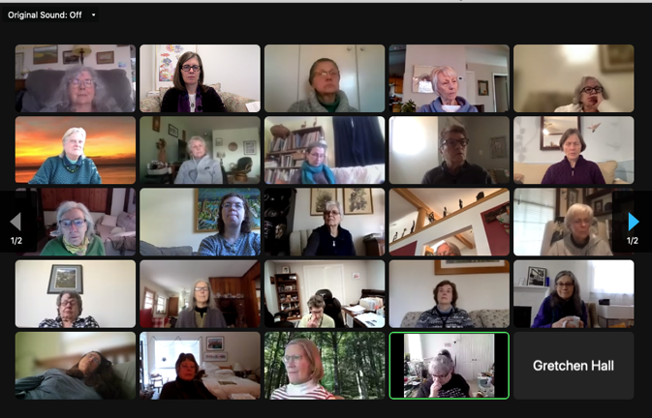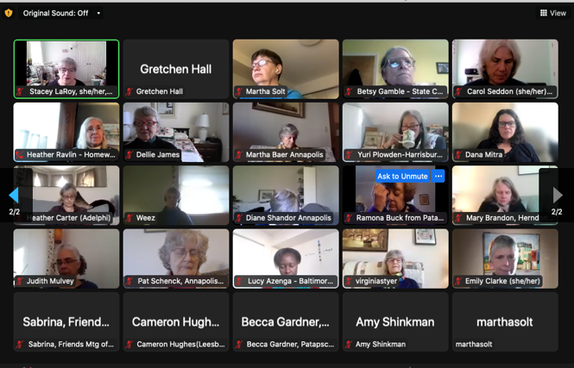

In 2022, the Working Group consisted of Inga Erickson (Herndon), Dana Mitra (State College), and Yuri Plowden (Harrisburg).

Because of Covid, the three of us on the working group elected to repeat the online Zoom two-hour format that we created in 2021. The gathering included worship sharing in Zoom breakout rooms, meeting for worship, and time for announcements and status updates for the 2023 retreat. We had assistance from the BYM office and Sarah Gillooly in sending out announcements and creating the registration for the retreat. It was held on Saturday, February 5th from 10-noon, and fifty women attended. We did not have a separate planning committee for the online retreat.

Dana and Yuri had agreed to serve with Inga when the 2021 retreat went online, and expressed a desire to step down from the Working Group after our 2022 retreat. During the retreat, we asked for volunteers to join the Working Group. Cameron Hughes (Goose Creek), Jodi Rose (Herndon), and Carol Seddon (Stony Run) all stepped forward.

The planning committee for the 2023 retreat remains uncertain, as no meeting or group of women has yet stepped forward with an offer to plan the retreat. A follow-up email went out to the participants, and an announcement will be placed in the BYM weekly announcements, asking for volunteers.

Although we trust that a future in-person retreat will eventually occur, it remains to be seen how the planning will come together. The responsibility of the Working Group is not to plan the retreat, but rather to ensure that it happens. Planning the retreat is a meaningful opportunity for service that is greatly appreciated by as many as 200 women in a well-attended year.

Respectfully submitted,
Inga Erickson, Dana Mitra, and Yuri Plowden
BYM Women’s Retreat Working Group

