Staff Report of the Camp Property Manager to Baltimore Yearly Meeting
David Hunter
November 2023

My 20th year as BYM Camp Property manager has been particularly busy and fulfilling. Some milestones were passed, farewells are being said and new opportunities are being embraced.
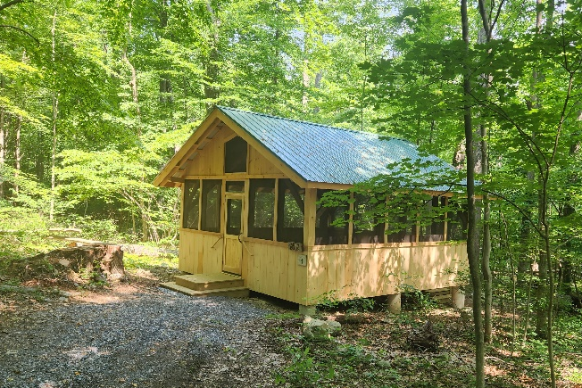
When I first started my work at BYM one of the first projects we took on was replacing each of the 12 camper cabins at Catoctin Quaker Camp. This spring, we finally replaced the last of them. This 20-year project was stopped in 2010 when Frederick County required us to provide a comprehensive, County approved site plan which turned out to be quite a project on its own. Now all the cabins are in good repair and beautiful examples of the splendor of simplicity, and all constructed of local materials. We continue to be grateful to Peter Bugler for helping us build these beautiful timber frame cabins at a generously reduced cost.

We have been looking for a new location for the program at Opequon Since before 2017. Our lease at Opequon was coming to an end and several problems with the site have surfaced over the years. Some of the issues include the driveway was prone to flooding, the site was a little small, there was no longer an adequate place to swim and many of the improvements that we anticipated needing to make in the years to come would have been expensive.
A joint ad hoc working group of the Camp Property Management Committee (CPMC) and the Camping Program Committee (CPC) had looked at several properties over the years and found that purchasing a new property would cost about one million dollars.
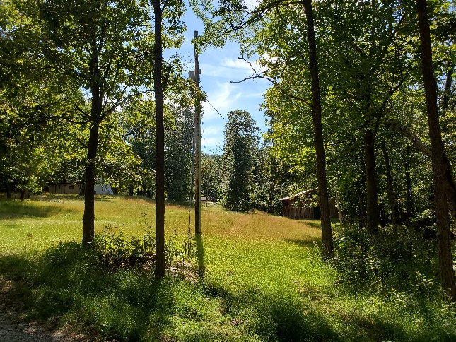
Fortunately, another possibility emerged! In the 1970s a family of Friends from Baltimore started a foundation near Harper's Ferry West Virginia which is now known as the Rolling Ridge Conservancy. Rolling Ridge is steward to over 1600 acres of land which sits between the Appalachian Trail and the Shenandoah River. At Rolling Ridge three organizations have partnered to fulfill the mission of the conservancy.
Until 2019 For the Love of Children (FLOC), a support and enrichment organization for children in Washington DC, filled one of the conservancy’s goals by offering young people a chance to connect with nature through their summer camping program and environmental education center. Unfortunately, in 2019 FLOC found it necessary to refocus their attention on their DC operations and sever their connection to Rolling Ridge Conservancy. Since then, Rolling Ridge has been seeking a new partner to fulfill that part of their mission.
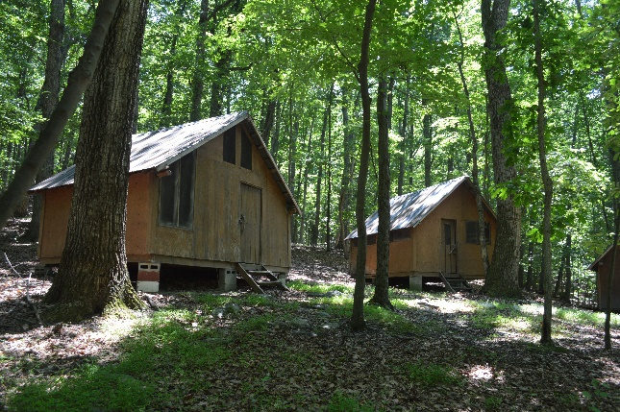
Over the last two years Friends from the Camp Property Management Committee, the Camping Program Committee and BYM staff have been meeting with Rolling Ridge Conservancy. At Interim Meeting in June, the yearly meeting approved a partnership between Rolling Ridge Conservancy and Baltimore Yearly Meetings Camping Program. Over the summer a lease was drafted and executed, and we have entered into a wonderful new partnership filled with exciting possibilities. In July, Opequon’s camp directors and Yearly Meeting staff met and decided that it would be feasible and desirable to have the new site ready for the 2024 camping season. The fun has begun!
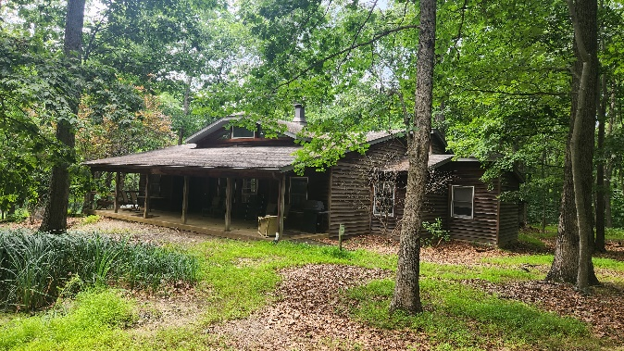
We have a lot to do before the 2024 camping season! However, much has already been accomplished. As the Opequon staff wrapped up their summer at the old site in Clearbrook they filled three PODS storage containers with furnishings and supplies that were then moved to the new site at Rolling Ridge. A small but mighty group of Opequon staff stayed on for an extra week to unload the containers. It was a heroic effort, well beyond what we have asked of staff in the past, and we are all profoundly grateful for the extra efforts! A workday was held this fall during which volunteers moved several more loads of equipment from the old site to the new one at Rolling Ridge. There are only a few items left to move and that will be accomplished by the end of the year.
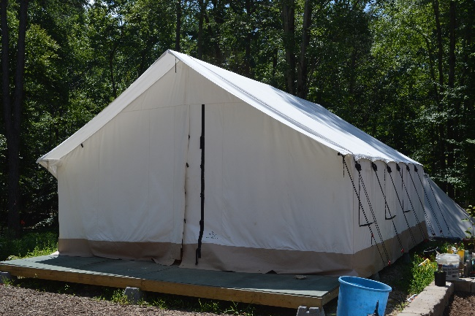
We have already hosted the first rental group at the new site and plans are well under way for the work that will need to be accomplished before the 2024 camping season. At a minimum, we will need to provide 50 beds for campers and cabin staff in 2024. We plan on accomplishing this by building 5 platforms. These platforms will be designed to accommodate either tents or cabins. It is likely that we will use several tents the 2024 camping season and look forward to building cabins on at least some of these platforms at a later date. We will also need to provide toilets in the cabin areas as well as the main campus, since the number of existing toilets is not adequate. We will also need to make some improvements to the driveway and trails around the camp and do a few other renovations and repairs around the camp before the 2024 camping season.
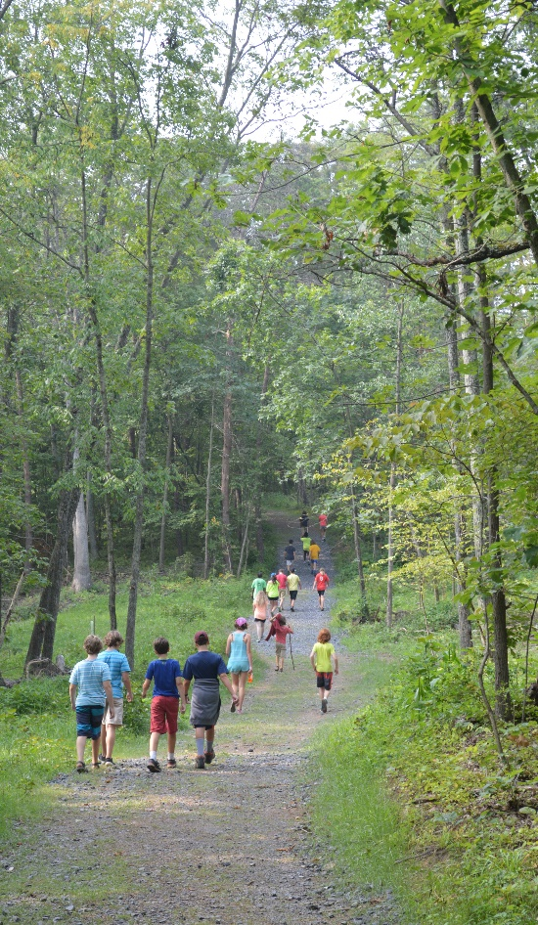
Opequon Quaker Camp has found its home on Circle Hill Farm for more than 3 of the last 5 decades. We cannot express our gratitude to the Pidgeon family for sharing their land and farm with us. Their family has been on the same land for over 300 years, and they were among the first Quakers to come to the Shenandoah Valley. It has been a real blessing to be steeped in such rich history on the banks of the Opequon creek for so many years. We will miss the place and we will miss the Pidgeons. We hope we will see them from time to time at the new site and that we will find opportunities to come back and see them at Circle Hill Farm.
You may have noticed that I have used “WE” when talking about all we have accomplished in this report. That is not by mistake. There are many, many people who give of themselves, of their time and of their resources to make camp possible. There are certainly times when I am working alone on the camp properties, but I am always aware that there are many others invested in the places and in the work. I feel and appreciate the presence of you all in those moments.
Some Friends have left a piece of their hearts at the camps as a spiritual investment, and many have given of their time and their financial resources to help make the camps possible. All that is given is deeply appreciated. When we take collective responsibility for a thing, we infuse it with something special. It comes to embody a unique Spirit, taking on a life of its own, enriching all that comes into contact with it.
I am ever grateful to be a part of an organization that values these programs and creating places for young people to grow and thrive. I feel immense pride when I look back and note how many of our former campers have grown into truly remarkable adults. They service the world in a thousand ways that simply make me stand in wonder. They are peacemakers, innovative farmers, climate activists, healers, social reformers, food security revolutionaries, artists bent on re-making the world, teachers of those who will shape the future and parents of the next generation of problem solvers. When I am able to steal a moment for a chat with one of them, we nearly always come around to recount a transformative experience that they had at camp and how it helped to mold them into the people they are today. Baltimore Yearly Meeting has created a space where young people are allowed to grow into people bent on making the world into a place that better reflects the community and the life in the Spirit they experienced at camp. I am grateful to the Yearly Meeting for giving this gift to our young people and for the gifts these young people are giving to the world!

