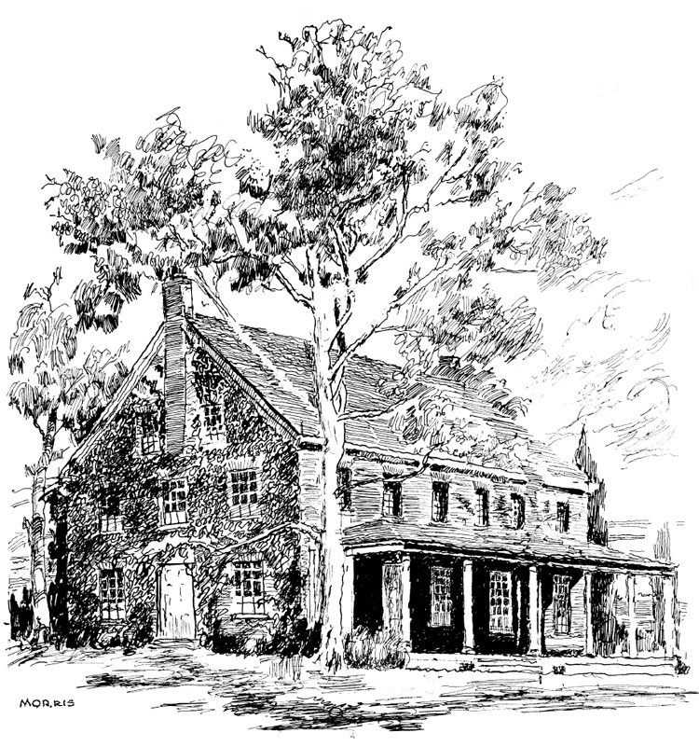
SANDY SPRING MONTHLY MEETING
OF THE RELIGIOUS SOCIETY OF FRIENDS
17715 MEETING HOUSE ROAD
SANDY SPRING, MARYLAND 20860
301-774-9792
e-mail: office@sandyspring.org
web site: www.sandyspring.org

The Sandy Spring Friends Meeting House

May 6, 2024

Greetings from Sandy Spring Monthly Meeting of the Baltimore Yearly Meeting of the Religious Society of Friends,
Patti Nesbitt, a member of Sandy Spring Monthly Meeting, has opened to us her leading to travel among Friends with a concern for aging and dying Friends. Informed by her work in palliative care nursing and nurtured by her support committee, her ministry focuses on teaching, minimizing suffering, and being a Friendly Presence to companion others as they face death.
Her concern has long been recognized to be true and valued by Friends both in our meeting and beyond. Her service as a Friendly Presence in support committees for those facing terminal diagnoses is well acknowledged. Her accompaniment has helped many Friends open difficult conversations and face hard decisions.
Patti has actively served in local meetings and Baltimore Yearly Meeting for over 40 years. While serving as clerk of Baltimore Yearly Meeting’s End of Life Working Group, she has co-authored a book called A Tender Time: Quaker Voices on the End of Life. She is now led to share her ministry in wider circles, facilitate workshops, and offer a listening heart as way opens.
Our Meeting unites with Patti’s leading and trusts you will find her time amongst you fruitful, prayerful, and enriching. We send you our loving greetings, and commend her to your care and hospitality.
Sincerely yours in the Light,
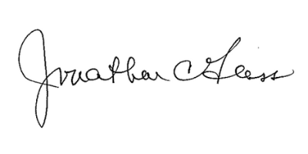
Jonathon C. Glass
Clerk, Sandy Spring Monthly Meeting

Approved by Ministry and Counsel Committee April 21, 2024
Approved by Monthly Meeting May 5, 2024

